**The high impact skills development program**

**(AI – DS)**

**Submitted by TOUSEEF KHAN**

**SECTION 4**

**PHASE II**

**Project link:**

**<https://prod-apnortheast-a.online.tableau.com/#/site/aalikhan22554-d39add6d8b/views/datavisualizationproject/Dashboard1?:iid=4>**

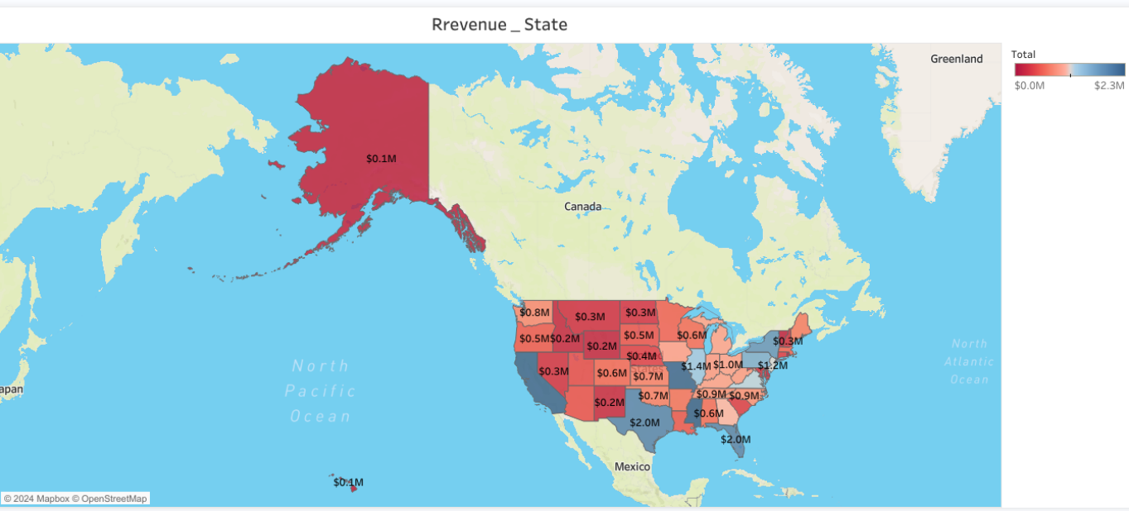

**Revenue by State**

### 1. ****Data Representation:****

* **Map**: A map chart has been used to visually represent revenue data by shading the states in different colors based on their revenue totals.
  + Darker red colors indicate higher revenue.
  + Lighter colors indicate lower revenue.

### 2. ****Revenue Labels on Each State:****

* The total revenue for each state is displayed directly on the map inside each state boundary. For example:
  + **Texas**: $2.0M
  + **Florida**: $1.4M
  + **California**: $0.8M
  + **Alaska**: $0.1M

### In summary:

The map visualizes revenue data across U.S. states by varying the color intensity of each state according to its revenue total. This gives an easy-to-understand, at-a-glance view of which states are generating the most and least revenue, with Texas and Florida standing out as major contributors

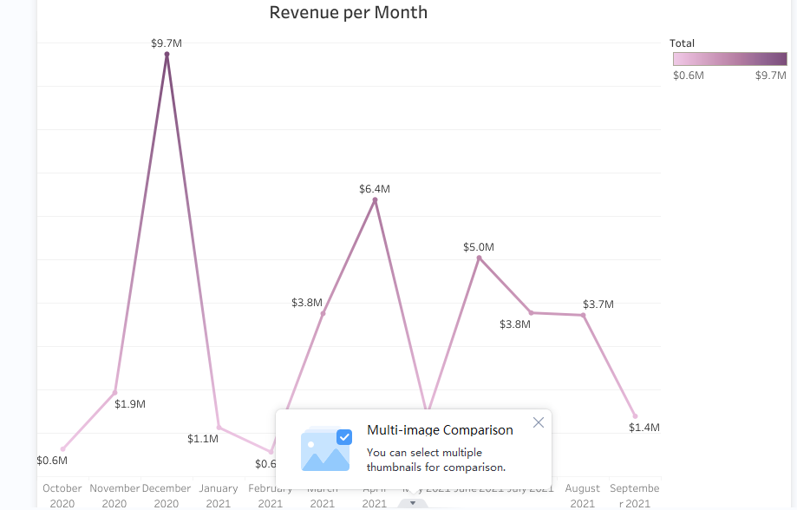

**Revenue per Month:**

The image represents a **line chart** depicting **monthly revenue trends** over a period from **October 2020 to September 2021**. Here's a breakdown of what has been done in this visualization:

### 

****Revenue Over Time:****

* The line chart plots revenue data for each month over a one-year period, showing **peaks** and **valleys** in revenue totals.
* The Y-axis represents the **revenue amounts** (in millions), ranging from **$0.6M** to **$9.7M**.
* The X-axis represents the **months**, starting from **October 2020** to **September 2021**.

### ****Line Gradient and Color Scale:****

* The line uses a gradient color that transitions from **light pink** to **darker purple** at higher revenue points, corresponding to the **legend** on the right side.
* The legend shows a scale from **$0.6M to $9.7M**, allowing viewers to understand the variations in color intensity relative to the revenue amounts.

### In summary:

This line chart presents the monthly revenue data over a year, showing significant fluctuations. The peak in December 2020 ($9.7M) contrasts sharply with the drop in February 2021 ($0.6M). The chart provides a visual representation of how revenue changes month by month, using color gradients to enhance clarity.

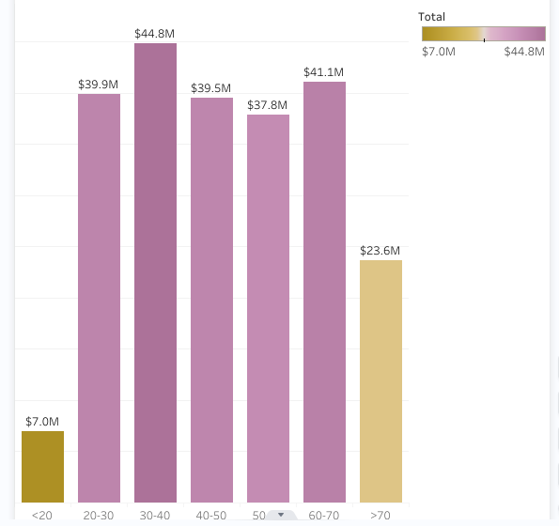

### 1. ****Revenue Grouped by Age:****

* The X-axis represents different **age groups**:
  + **<20**
  + **20-30**
  + **30-40**
  + **40-50**
  + **50-60**
  + **60-70**
  + **>70**
* The Y-axis represents **revenue amounts** in millions of dollars.

### 2. ****Revenue Amounts:****

* Each age group’s revenue is represented by the height of its respective bar. The revenue amounts are also labeled at the top of each bar:
  + **<20**: $7.0M (smallest revenue)
  + **20-30**: $39.9M
  + **30-40**: $44.8M (highest revenue)
  + **40-50**: $39.5M
  + **50-60**: $37.8M
  + **60-70**: $41.1M
  + **>70**: $23.6M

### 3. ****Color Gradient for Revenue:****

* The bars are colored using a gradient scale, where darker purple indicates higher revenue, and lighter colors (yellowish tones) indicate lower revenue.
* The legend on the right shows that the range of revenue is from **$7.0M to $44.8M**.

### In summary:

This bar chart illustrates the revenue contributions from different age groups. The **30-40 age group** is the largest contributor, while **<20** and **>70** age groups generate significantly less revenue. The chart uses a gradient color scale to visually distinguish between higher and lower revenue amounts across the age ranges.

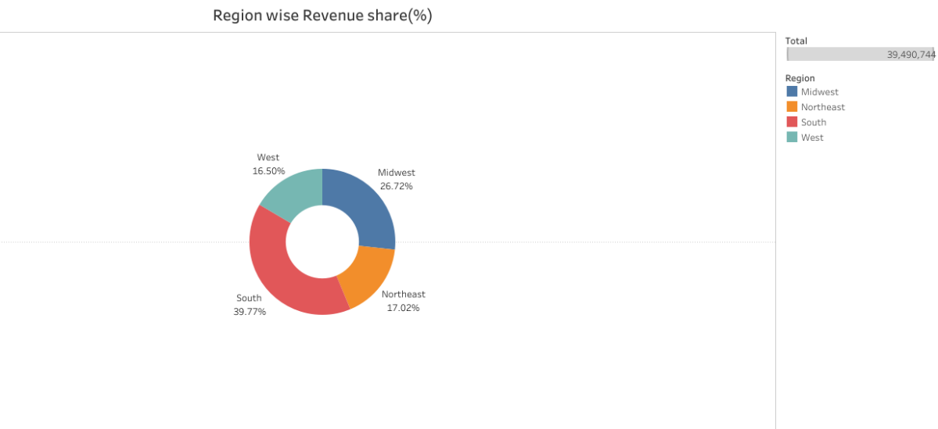

The revenue share for each region:

* **West:** 16.50%
* **Midwest:** 26.72%
* **Northeast:** 17.02%
* **South:** 39.77%

The chart visually represents the relative contributions of each region to the overall revenue. The largest share of revenue comes from the South region, followed by the Midwest. The West and Northeast regions have relatively smaller shares.

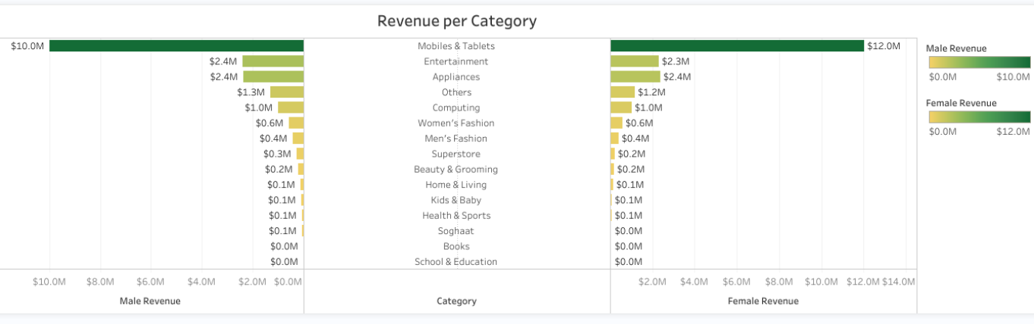

The chart is titled "Revenue per Category" and is divided into two sections: one for male revenue and one for female revenue. Each section shows a bar chart with the product categories on the x-axis and the revenue on the y-axis. The bars are colored green for male revenue and yellow for female revenue.

Here are some key observations from the chart:

* **Mobiles & Tablets** is the top-selling category for both male and female customers.
* **Entertainment** and **Appliances** are also popular categories for both genders.
* **Women's Fashion** and **Men's Fashion** are the top-selling categories for each respective gender.
* **Beauty & Grooming** and **Home & Living** are also popular categories for women.
* **Computing** and **Others** are relatively low-revenue categories for both genders.
* **Superstore**, **Kids & Baby**, **Health & Sports**, **Soghaat**, **Books**, and **School & Education** have minimal revenue for both genders.

Overall, the chart provides a clear visualization of the revenue generated by different product categories for male and female customers. It helps to identify the most popular categories and the areas where there is potential for growth.